Assignment - Querying Basics

Date 20/04/2023

Querying the Database:

Q1) Display the EMPL Table

Ans- Select * from EMPL;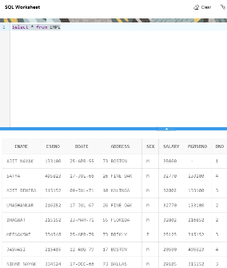

Q2) List the employees who work in Department No. 3 and 4

Ans-

1.Select ENAME, DNO from EMPL

WHERE DNO = 3 or dno = 4;

2.Select ENAME, DNO from EMPL

WHERE DNO in(3,4);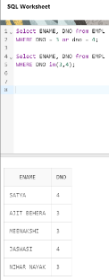

Q3) From the PROJECTS table, find the PNUMBER of KOREA

Ans-

Select PNUMBER, PLOCATION from PROJECT

Where PLOCATION='KOREA';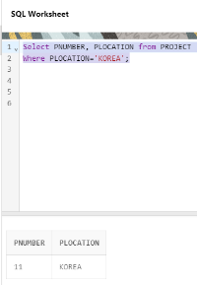

Q4) List the SUM of working hours of each project from WORKS_ON

Table. (Hint: You need to group based on PNO)

Ans-

Select PNO, SUM(HOURS) from WORKS_ON

GROUP BY PNO;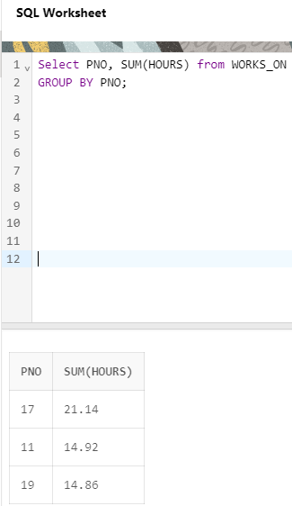

Q5) Display the DEPARTMENT LOCATIONS in ascending ORDER from

the DEPT_LOCATIONS table.

Ans-

Select * FROM DEPT_LOCATIONS

ORDER BY DLOCATION;

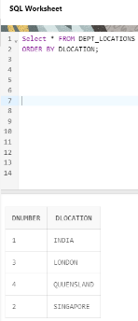

Q6) List the SUM of working hours of each employee from WORKS_ON

Table HAVING SUM of working hours greater than 10. (Hint: You need

to group on the basis of ESRNO)

Ans-

Select ESRNO, SUM(HOURS) FROM WORKS_on

GROUP BY ESRNO

HAVING SUM(HOURS)>10;

